MARJOLIN, Robert Ernest, French civil servant and first Secretary-General of the Organisation for European Economic Cooperation (OEEC) 1948-1955, was born 27 July 1911 in Paris, France and passed away 15 April 1986 in Paris. He was the son of Ernest Octave Marjolin, salesman, and Elise Vacher, laundress. On 2 September 1944 he married Dorothy Thayer Smith. They had one daughter and one son.

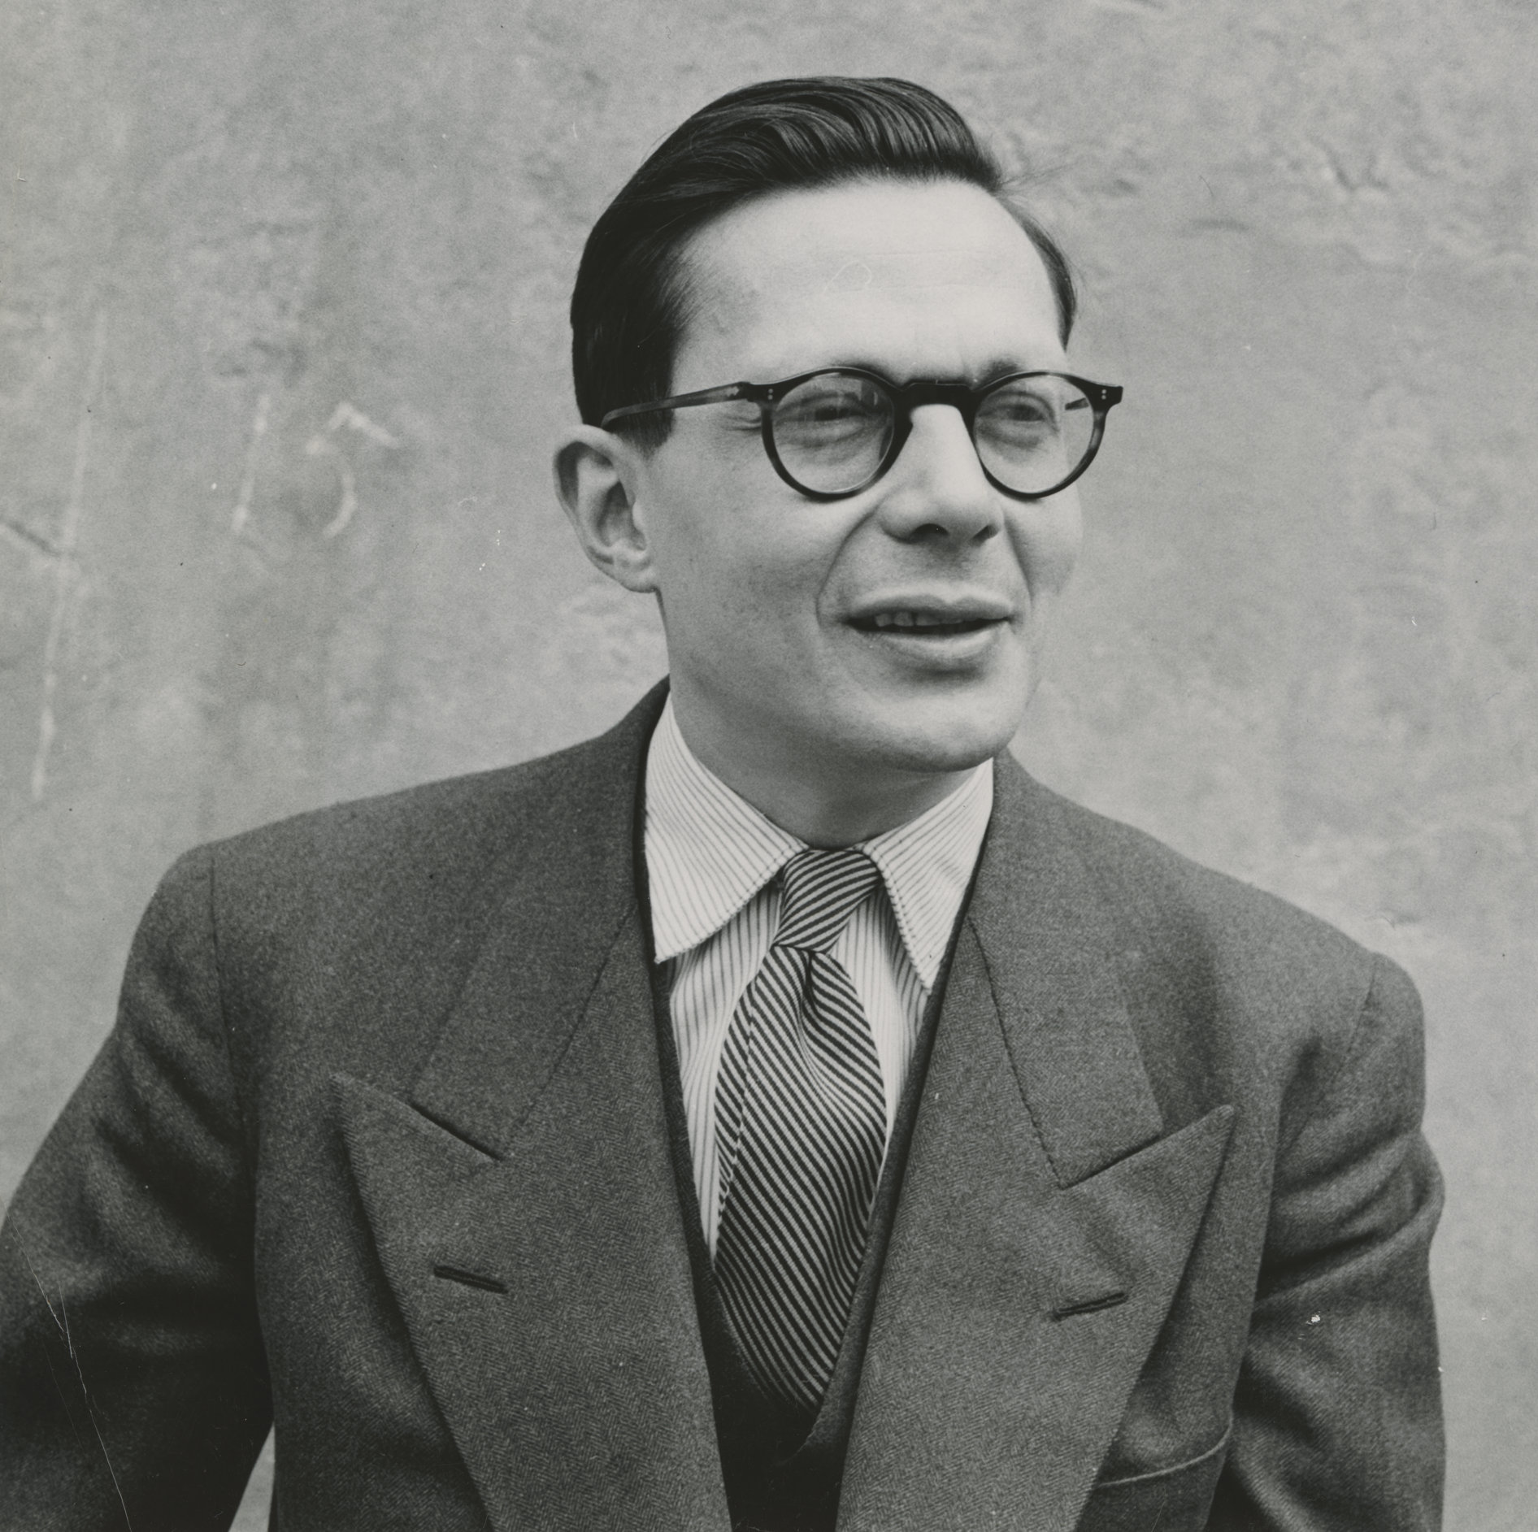
Source: Fondation Jean Monnet pour l’Europe, Lausanne

Marjolin grew up in modest surroundings. Both parents were illegitimate children. His father worked as a carpenter, upholsterer and salesman, while his mother, who had been a laundress before her marriage, did cleaning when the family was in need of money. Marjolin’s sister left school when she was 12 to work as a seamstress and he himself left school at the age of 14. After working different manual jobs over several months, he found a position as clerk for a Parisian stockbroker, thanks to a former army comrade of his father. Marjolin resumed his studies at the age of 18, but since he had not passed the baccalauréat required to enter university, he studied for a diploma of the École pratique des hautes études (EPHE) at the Sorbonne University, which did not require a high school degree for admission. At the EPHE Marjolin met later prominent French intellectuals such as Raymond Aron and Georges Friedmann, who became lifelong friends for him. Thanks to the support of his philosophy professor, Célestin Bouglé, he travelled to the United Kingdom and then, with a Rockefeller fellowship, spent one year studying sociology and economics at Yale University in the United States (US) between 1932 and 1933. During this stay he collected materials for a monograph on US trade unionism, which was published in 1936. Upon returning to France in 1933 he received his licence de philosophie and from 1934 until 1939 he worked under the supervision of the economist Charles Rist, an early partisan of John Maynard Keynes, at the Institut scientifique de recherches économiques et sociales. He studied at the law faculty of the University of Paris, received his degree in law in 1936, and then began work on his dissertation on the long-term evolution of prices, currency and production.
In 1929 Marjolin joined the French Socialist party (SFIO, Section française de l’internationale ouvrière). He was involved in the cooperative movement and connected with Révolution constructive, a group of young socialist intellectuals. When he returned from Yale in 1933 the moderate left-wing politician Léon Blum invited Marjolin to edit the economic section of the socialist newspaper Le Populaire. In 1936 Marjolin joined Blum’s Popular Front administration as a civil servant, but one year later clashed with Blum because of his non-intervention policy toward the Spanish civil war. He also disapproved of Blum’s belated devaluation of the French Franc and strongly opposed the 40-hour workweek, which he believed to undermine economic growth. He left the French Prime Minister’s staff in 1938 and started to write for the newspaper Europe nouvelle, in which he expressed his concerns about what he later termed French economic decadence (1986: 68-72). He also joined intellectual economic circles such as the neoliberal Walter Lippmann Colloquium, formed in Paris in 1938. The 1939 military mobilization prevented him from defending his dissertation, although he later received his doctorate in economics in 1945. At the beginning of the Second World War Marjolin became a sergeant in the French army, but was soon appointed statistician to the Franco-British Economic Co-ordination Committee, chaired by Jean Monnet, in 1940. After the Germans defeated the French, Marjolin returned to France. Under appointment by the French government in Vichy he spent a short time in Morocco, but decided to switch political sides and during the spring of 1941 he left for London, where he joined Free France, the resistance movement led by General Charles de Gaulle, and wrote contributions for Aron’s journal La France libre. From 1941 to 1944 Marjolin was appointed to different administrative capacities in the Comité français de libération nationale in both London and (from 1943) Washington DC, where he assisted Monnet, who de Gaulle had put in charge of planning the French postwar supply of food and raw materials. Marjolin took advantage of this time to learn more about national accounting and to read Anglo-Saxon economic literature. In February 1944 Marjolin met his future wife Dorothy Smith in Washington. She was the daughter of a wealthy West Virginian family and had studied at Smith College, a women’s liberal arts college in Northampton, Massachusetts. After the liberation of Paris in August and their marriage in September the Marjolins returned to France, where he was named head of foreign economic relations in the Ministry of National Economy. He favoured strong state control over economic development and worked in association with Monnet on policies for French economic recovery.
Following the announcement of the US Marshall Plan in June 1947 delegates of 16 European countries formed the Committee of European Economic Cooperation, which set out to elaborate a common European recovery programme. Marjolin joined the French delegation as Deputy Director. He viewed this committee as an opportunity to fit French economic recovery into a European plan and became its de facto Secretary-General, spending several months travelling and meeting with European representatives in Rome and Bern. With the signature of the Foreign Assistance Act, known as Marshall Plan, by US President Harry S Truman the Organisation for European Economic Cooperation (OEEC) was created on 16 April 1948, with headquarters established in the Château de la Muette in Paris and Marjolin officially appointed as the organization’s first Secretary-General. While the US trusted Marjolin and favoured a strong Secretary-General, but at first had considered candidates from smaller countries, French and British officials had manoeuvred since January to get Marjolin nominated. They, however, did not want to give too much power to the Secretary-General and expected Marjolin to act as a faithful civil servant who would respect their policy choices. Inspired by Keynes’ work The Economic Consequences of the Peace (1919), Marjolin was convinced that the origins of the economic crisis of the 1930s could be found in the international economic policies after the First World War and believed that post-1945 reconstruction should have nothing in common with the previous situation. Furthermore, having worked with Monnet, their shared commitment to the European idea strongly influenced Marjolin’s policy making as OEEC Secretary-General. He viewed his position as an opportunity to strengthen European efforts toward economic collaboration, believing that France’s economic recovery should take place within a wider European effort. His tenure as Secretary-General can be divided in two periods, the first (1948-1952) closely associated with the reconstruction of Europe and the European Recovery Program (ERP), the second (1952-1955) with economic development and productivity issues.
During the first period the OEEC practically existed through American policy making and the ERP. Marjolin closely collaborated with the US administration by showing how the money was used and justifying the continuation of aid flows. The US Economic Cooperation Administration (ECA), headed by Paul Hoffman, had W. Averell Harriman as its representative in Paris, where he coordinated the ERP. Tensions arose between Harriman and Marjolin, who began to draw demarcation lines between the ERP and the OEEC and also strove to increase the organization’s autonomy from both the US and the member states. Another sensitive issue was the OEEC’s role in the repartition of Marshall Aid between the member states. Lack of coordination between beneficiaries in the preliminary stage of establishing resource requirements raised the repartition problem. Marjolin favoured a repartition key established by the OEEC. The ECA eventually decided that the use and repartition of aid between member states would be integrated within the ERP, drawn up by the OEEC, but with the final decision left to the Americans. Hoffman, who addressed the OEEC Council in July 1948, asked for a conclusive ERP to be achieved in June 1952 when US aid would end. Between December 1948 and January 1949 Marjolin was in the US in order to prepare a plan to be submitted to Congress and also met with Senators who were concerned about the use of the Marshall Plan funds. Harriman estimated that the money was ‘reasonably well spent’, but Senators Thomas T. Connolly and Arthur H. Vandenberg expressed concerns about the risk that US taxpayers would shoulder the burden of European reconstruction indefinitely (Archives Robert Marjolin, ARM 4/2/13, Note on discussion with US Senators and Congressmen, 18 January 1949). They criticized the provisional long-term report because of its imprecise nature and expected excessive budget. They did not believe in a long-term plan in general since it was impossible to know what Europe would look like in 1952-1953. However, they emphasized the necessity of showing Congress that the European need for US aid and the ERP would end in 1952. Europe was always considered as a whole in the discussions between ECA representatives, US Senators and Marjolin, without reference to the needs of specific states. In this regard the debates contributed to building a European entity. American high-level civil servants and Senators envisioned the OEEC and the ERP as tools to unify Europe. They did not want to negotiate with every single state, but instead used the OEEC as an interface to make all beneficiaries speak with one voice, and regarded this task as the mission of the Secretary-General, who had to make the member states cooperate and draw up collective policies. When Marjolin (1986: 209-212) later reviewed his achievements in this respect, he underlined his failure to establish real economic cooperation through the OEEC.
The autonomy advocated by Marjolin also concerned the way in which the OEEC should treat its civil servants. Marjolin’s staff policy included the approval of the governments to hire new employees, but once they had joined the organization he considered himself to be independent in his decisions concerning staff. He would not dismiss anyone just because a government asked him to do so (ARM 4/12/3, Compte-rendu de la conversation avec M. William Batt, dimanche 14 juin 1953, stric. confidentiel). This policy strengthened the autonomy of the Secretariat vis-à-vis the member states. The first high-level OEEC civil servants were all relatively young when appointed. They were born at the beginning of the century and had been too young to serve during the First World War, but had experienced the economic crisis of the 1930s. In his memoirs Marjolin (1986: 187) wrote that, when preparing the organization, he noticed that he got on well with both American and British Keynesian economists, who all belonged to the ‘generation of growth’. These people also shared a national rather than international civil servant profile. Except for one staff member who came from the International Bank for Reconstruction and Development, none had experience within an international organization such as the Economic and Financial Organization of the League of Nations. One of Marjolin’s first, and particularly imperative, missions was to help standardize national income data and enhance the statistical production of all member states, because such data was necessary for implementing the ERP. Marjolin also needed to solve financial problems, notably the ‘dollar gap’ or lack of US dollars in the European economy, which had resulted in large balance of payment problems. The OEEC experts tried to solve these problems by considering the OEEC as a whole and by collectivizing the member states’ balances of payments. This was the basic idea of the European Payment Union (EPU). Long negotiations resulted in an international treaty, signed in September 1950, which created the EPU for two years. By origin this was a US initiative aimed to free the US from the costs of intra-European trade, but the EPU made European payments multilateral and introduced a compensation system. At the end of every month the Bank for International Settlement established the accounts, while debtors had to pay their debts in principle with gold. This method enabled the collectivization of European profits and deficits toward the US. The EPU, which lasted seven years in total, was successful as it mutualised clearing among European states and allowed 70 per cent of the intra-European trade to be settled without gold or currency.
According to Marjolin and his staff, economic recovery should be rationally founded and productivity was in the centre of their concerns. Some of the staff had travelled to the US in order to study productivity improvement measures in order to adapt these to help modernize European industry. A first working party on scientific and technical information was created and resulted in the foundation of the European Productivity Agency (EPA) in 1953. During the second part of his tenure Marjolin did not seem to be strongly involved in this process, although the EPA was part of the OEEC and financed by Marshall Plan funds. Rather it was the work of Alexander King, a British scientist and productivity expert at the OEEC. King (2006: 221) emphasized that ‘research should be supported as a long-term economic investment’ and believed that collaboration in applied sciences between OEEC member states should be strengthened in agriculture, industry and services. When describing the beginnings of the productivity issue in his memoirs, King (2006: 220-226) does not mention Marjolin, except with regard to issues that involved EPA Director Karl Harten. In the early 1950s Marjolin’s attention was drawn toward other concerns. One of the largest was the recently created North Atlantic Treaty Organization (NATO), which was soon put at the centre of his attention due to the Korean War. The West was preparing for war and European recovery took a back seat. Marjolin was convinced that the military effort was necessary, but continued to underline the importance of sustained economic growth and monetary stability. For him victory by the West had to be based on its economic system. While rearmament did not slow down the increase of production and the development of intra-European trade, it worsened the dollar deficit and drew some inflationary tendencies. Furthermore, Marjolin had to manage the tensions between the US wish to see Europe involved in international security and the significant reorientation of aid from economic to armament matters and the European need to sustain purchasing power while increasing the defence effort. The position of the OEEC vis-à-vis NATO was the subject of intense debate. For Marjolin (1986: 238) the question was important because the OEEC economists had built a reputation of great abilities since 1948 and, thus, it was difficult to rapidly gather another equally qualified group of experts. Some states openly spoke in favour of the OEEC’s dissolution, as the organization was directly linked to the Marshall Plan and accordingly should disappear with the reorientation of US aid, but some neutral states did not wish to simply replace the OEEC with NATO. Both organizations proved able to collaborate and Marjolin even supervised a NATO Council commission of economists who aimed to analyse the states’ capacity for an armament increase. In this case Marjolin did not fight to maintain the OEEC as the organization stood because European unity seemed more important for him than the mere existence of the OEEC. Eventually NATO’s economic and financial commission was dissolved, with the OEEC taking over responsibilities for economic and financial issues and studies. Marjolin, who had been active in the OEEC’s first period when the organization was devoted to the reconstruction of Europe, saw his commitment weakened after the end of the Marshall Plan. In his memoirs he (1986: 246-247) wrote that he already thought about leaving the organization between 1952 and 1953. He went through a moral crisis, wondering what to do. He believed that the European project had gotten stuck because of the resistance of OEEC member states against the customs union project, aimed to stimulate intra-European trade by removing tariffs barriers, for which he was campaigning. It took him two years to free himself from his obligations toward the organization and, in April 1955, he left without any further appointment.
After departing the OEEC, Marjolin taught political economy at the University of Nancy and, in 1956, joined the staff of Foreign Affairs Minister Charles Pineau. This position in the administration occurred at a critical moment in the European integration process. The so-called Spaak Report, the programmatic document written by Belgian politician Paul-Henri Spaak in April 1956 in favour of the creation of a European economic community, had not enjoyed the support of the former French government. The French attitude changed with the new government. Some ministers and their staff, among them Marjolin, had been involved in liberal pro-European networks such as the Walter Lippmann Colloquium and the Bilderberg Group, created in 1952 to stimulate contacts between Europe and the US in the fight against communism. These networks served as social circles between European economists, politicians and civil servants and as forums to exchange ideas to renew liberal thought. The economic ideas represented in these circles were heterogeneous, comprising both ordo-liberal thinkers, who, particularly in Germany, emphasized free-market rules with the state restricting itself to enabling and supervising these rules, and Keynesians. The proposed common market was regarded as a tool for large-scale economic rationalization, which could strengthen productivity and provide dynamism for industrial development. Eventually the French government agreed with the Spaak Report in May and Marjolin became Vice-President of the French delegation for the common market negotiations in 1956-1957.
On 1 January 1958 Marjolin left the French civil service for the newly created Commission of the European Economic Community (EEC), led by Walter Hallstein. Recruited as one of the two French Commissioners, he became responsible for economics and finance and was Vice-President of the Commission. He resumed his collaboration with Monnet, who was still involved in European integration through his Action Committee for the United States of Europe, and tried to stimulate economic policy coordination within the EEC in a way that was not so different from what he had done at the OEEC. Marjolin aimed to develop planning at the European scale as a technical issue, which would allow for economic rationalization. In order to create a network of European planning experts he strengthened the Commission’s expertise capacity by recruiting civil servants who were keen to support his ideas. In 1962 the Commission issued the report Economic Development Prospects in the EEC from 1960 to 1970, which stressed the necessity of bringing all national programmes and previsions together before they could be coordinated in a common vision. In 1963 Marjolin submitted his first proposal to the Council with a middle-term economic policy for the years 1964 and 1965. Eventually a middle-term economic policy committee was created in order to elaborate economic policy programmes for the EEC and the six member states. Marjolin also wanted to stimulate trade between the member states. When strong economic growth occurred in the 1960s, the Commission believed that domestic demand needed to be managed, if necessary also by fiscal means, in order to keep inflation under control and eventually stabilize the exchange rates of the member states. Following from Marjolin’s involvement in industrial policies, the Commission’s first project aimed to create a large and homogeneous internal market for European companies in order to enable their growth where policies should support agreement between companies to increase their competitiveness and capacity for research and development. Marjolin took part in the elaboration of measures supposed to reach these goals, such as the suppression of non-tariffs barriers (for example, technical norms), the coordination of domestic policies and sectoral aid and harmonization in some sectors in crisis, such as the shipbuilding industry. In these matters Marjolin faced the opposition of the ordo-liberal tendency embodied by German Commissioner for competition, Hans von der Groeben, who was in favour of a more competition-oriented policy, in which national governments had no functions other than securing and arbitrating the free exercise of the market. When Marjolin left his position as European Commissioner on 1 July 1967, he once again had the bitter feeling of not having succeeded in a project that mattered to him.
Between 1967 and 1969 Marjolin was professor of political economy at the Law and Economic Science Faculty of the University of Paris II (Panthéon-Assas). From the end of the 1960s he became involved in business activities as a member of the boards of Royal Dutch/Shell (1969-1986) and Robeco (1970-1981) and of the advisory councils of Chase Manhattan Bank (1967) and General Motors (1972-1981). He was also appointed as an adviser to IBM (1971-1984), American Express (1972) and the European Council (1978). In 1984 he was elected as a member of the French Académie des sciences morales et politiques. He died in 1986, a few years after his wife. His obituary in Le Monde of 17 April 1986 stated: ‘Robert Marjolin ... embodied successively happiness, a kind of disillusion, grief, and maybe during the last years some serenity’. Throughout his life Marjolin served as a politician, an academic economist, a national or an international high-level civil servant, and, eventually, a business adviser. He was appointed twice to international organizations through which he could contribute to building Europe as an economic and political entity. He was convinced that the prosperity of European societies relied on cooperation between countries and managed to implement some of his ideas and contribute to European unity, but he was also disappointed when he proved incapable of fully reaching his aims. Politically Marjolin (1986: 370) regarded himself as a liberal ready to agree with a moderate Socialist programme and, as an economist, he promoted coordination and collaboration between European states and planning institutions. Inspired by Keynes’ legacy, he was committed to long-term economic planning in order to sustain full employment and high living standards.

ARCHIVES: Robert Marjolin’s Archives are at the Fondation Jean Monnet pour l’Europe in Lausanne, Switzerland: www.jean-monnet.ch/site/archives/78/149, in particular Dossier ARM 3: La Genèse de l’OECE and Dossier ARM 4: Travaux de l’OECE.
PUBLICATIONS: L’évolution du syndicalisme aux États-Unis, de Washington à Roosevelt, Paris 1936; Prix, monnaie et production: Essai sur les mouvements économiques de longue durée, Paris 1941; Europe and the United States in the World Economy, Durham, NC 1953; ‘Un mode de penser européen’ in L’OECE au service de l’Europe, les activités de l’Organisation Européenne de Coopération Économique, Paris 1954, 15-19; ‘French Economic Problems in the Atomic Age’ in The Listener, 54/1395, November 1955, 877-878; ‘Prospects for the European Common Market’ in Foreign Affairs, 36/1, 1957, 131-142; ‘Coopération intergouvernementale et autorités supranationales’ in Revue économique, 9/2, March 1958, 267-277; Les problèmes économiques du Marché Commun en 1964, Paris 1964; La croissance économique en Europe et aux États-Unis, Paris 1971; Investissement publics et calcul économique, Paris 1973; Rapport de la Commission Relations économiques et financières avec l’extérieur, Paris 1975; Report on European Institutions, Luxembourg 1979 (with B. Biesheuvel and E. Dell); Europe in Search of Its Identity, New York 1981; Le travail d’une vie: Mémoires 1911-1986, Paris 1986, in English: Architect of European Unity: Memoirs 1911-1986, London 1989.
LITERATURE: A. Rothe and C. Ellis, ‘Marjolin, Robert (Ernest)’ in Current Biography: Who’s News and Why, 1948, 1949, 415-417; J. Gibson, Interview Robert Marjolin [Vice-President of the Commission of the European Communities], Washington DC 27 September 1963, at http://aei.pitt.edu/14320/; Oral History Interviews with Robert Marjolin, 30 May 1964 (by P.C. Brooks) and 2 July 1971 (by T.A. Wilson), at Harry S Truman Library & Museum in Independence, Missouri, at www.trumanlibrary.org/oralhist/marjoln.htm; E.H. van der Beugel, European Integration as a Concern of American Foreign Policy: From Marshall Aid to Atlantic Partnership, Amsterdam 1966; ‘Marjolin, Robert Ernest’ in Who’s Who in France, Paris 1984-1985, 971; J. Maisonrouge, Manager International, Paris 1985; Le Monde, 17 April 1986; J. Calverley and R.R. O’Brien (Eds), Finance and the International Economy: The AMEX Bank Review Prize Essay. In Memory of Robert Marjolin, Oxford 1987 (and later); A.S. Milward, The Reconstruction of Western Europe, 1945-51, London 1987; G. Defossé, Notice sur la vie et les travaux de Robert Marjolin, Paris 1989, Publications de l’Institut de France, nr. 6; Notices biographiques et bibliographiques: Membres titulaires, associés étrangers en date du 1er janvier 1990…, Paris 1990, 426-427; Colloque du mardi 9 décembre 2003 consacré à Robert Marjolin, Paris 2004, Publications de l’Institut de France, nr. 5; A. King, Let the Cat Turn Round: One Man’s Traverse of the Twentieth Century, London 2006; M. Dumoulin (Ed.), The European Commission, 1958-72: History and Memories, Brussels 2007; L. Warlouzet, ‘Europe de la concurrence et politique industrielle communautaire: La naissance d’une opposition au sein de la CEE dans les années 1960’ in Histoire, économie et société, 27/1, 2008, 47-61; F. Denord and A. Schwarz, ‘L’économie (très) politique du traité de Rome’ in Politix, 89/1, 2010, 35-56; L. Warlouzet, Le choix de la CEE pour la France: l’Europe économique en débat de Mendès-France à de Gaulle (1955-1969), Paris 2011; Ch. Boillaud, ‘La genèse de la CEE: Une coproduction des technocrates, des politiques et du patronat?’ in Politique européenne, 41/3, 2013, 164-176; M. Schmelzer, The Hegemony of Growth: The Making and Remaking of the Economic Growth Paradigm and the OEEC/OECD, 1948-1974, Viadrina 2013 (all websites accessed on 9 May 2014).

Alix Heiniger

Version 2 June 2014

How To Cite This IO BIO Entry?
Alix Heiniger, ‘Marjolin, Robert Ernest’ in IO BIO, Biographical Dictionary of Secretaries-General of International Organizations, Edited by Bob Reinalda, Kent J. Kille and Jaci L. Eisenberg, www.ru.nl/fm/iobio, Accessed DAY MONTH YEAR

